Release Radar - Hackathon Build Plan & MVP

Product summary
Release Radar tells a Fusion Cloud customer, in minutes, which of their own customizations the next quarterly update will break, which need testing, and which new features they should switch on. Today that answer takes an admin or SI team one to two weeks of reading What's New pages against spreadsheets.
One-line pitch: "Upload your configuration, pick the release, get a ranked impact report with the regression tests already written."
Target user: Fusion application administrators, CX/ERP/HCM functional leads, and SI release-management teams.
What they do today:
- Download the What's New and feature-summary spreadsheets for each module (often hundreds of features per release).
- Manually cross-check against their Groovy scripts, App Composer objects, Page Composer changes, workflows, OIC integrations and reports.
- Guess impact, write regression tests by hand, and still get surprised in the test pod.
How Release Radar helps: it matches every release feature to the affected configuration objects, classifies each match as Breaking, Needs testing or Opt-in opportunity, cites the release note behind every flag, and generates test cases plus a one-page summary for the steering committee.
Demo release: 26D (the next update after today's date). Use real What's New items for credibility; the customer configuration is a fictional company, "Northwind Telecom".

MVP scope
The MVP is one flawless path: pick customer and release, run analysis, review ranked findings with citations, open generated test cases, download the summary. Everything else is cut until that path works on the live URL.
Priority | Feature | Why it matters for scoring
Must | Load 20-30 real 26D What's New items for Fusion Apps (title, module, description, opt-in flag) | Real data makes Demand credible
Must | Load ~25 Northwind config objects across 6 types (Groovy, App Composer object/field, Page Composer change, workflow, OIC integration, BIP/OTBI report) | Shows breadth of what is checked
Must | Vector match + LLM classification into Breaking / Needs testing / Opt-in opportunity, with confidence | Proper, grounded use of AI
Must | Every finding cites the release-note text it came from | Answers "is this hallucinated?"
Must | Generated regression test case per finding (steps + expected result) | The key action the app makes easier
Must | APEX app, live URL, demo login, results dashboard | Technical Execution (20%)
Should | One-page exec summary (counts by severity, top 3 risks, effort estimate) | Before/after story for judges
Should | Upload your own config CSV/JSON | Proves it is not hard-coded
Could | Export test cases to CSV | Nice touch, 15 minutes
Could | Compare two releases | Only if ahead of plan
Out | Live connection to a Fusion pod via REST | v2 roadmap item
Out | Auto-scraping Oracle docs | Paste items manually today

Architecture on OCI
The whole pipeline lives in one Autonomous Database: embeddings and the LLM verdict come from OCI Generative AI, vector matching narrows the candidates, and APEX serves the live URL.
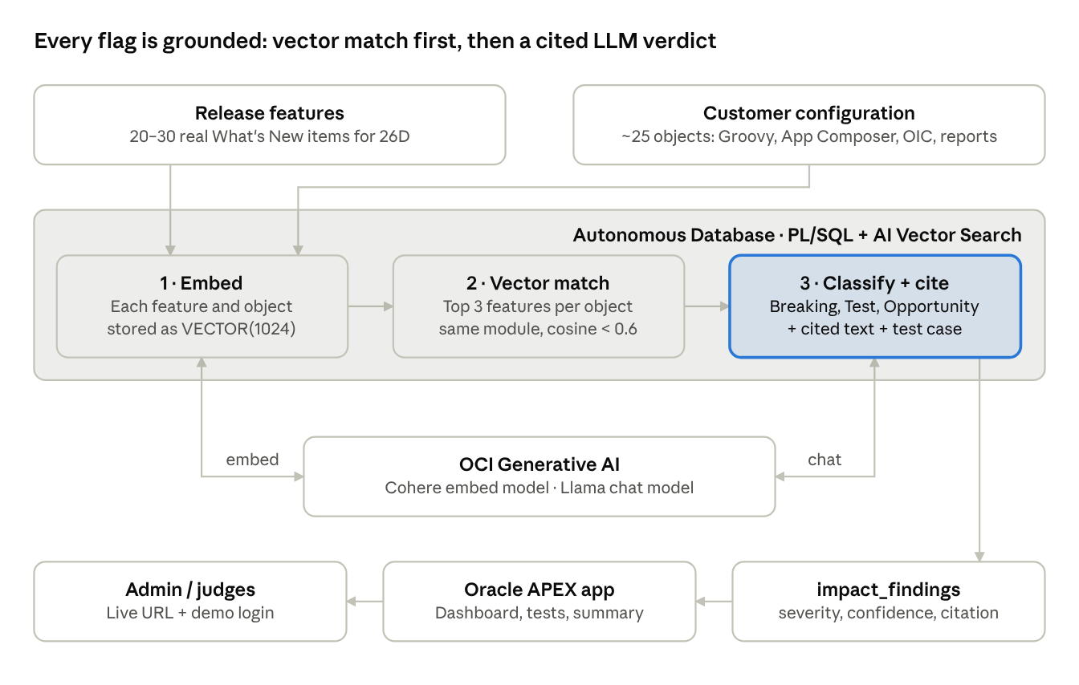
Release Radar architecture · 3 pipeline steps inside Autonomous Database
Vector search keeps the LLM focused on a few plausible pairs per object, which cuts cost and false flags; the LLM then has to quote the release text it relied on.

Data strategy
Two small, curated datasets beat a big scraped one today: real release items for credibility, and a fictional customer config with planted impacts so the demo lands every time.
1. Release features (real). From Oracle's What's New for Fusion Apps, copy 20-30 items for the demo release into a CSV: release, module, feature title, short description, "customer action required / opt-in" flag. Oracle's own feature-summary tables already mark opt-in features; reuse that signal rather than having the LLM guess it.
2. Customer configuration (fictional "Northwind Telecom"). About 25 rows, each with: object type, name, module, a 2-4 line description, and a code or config snippet where relevant.
Object type | Count | Example
Groovy script / object function | 5 | Opportunity validation that blocks close without a signed quote
App Composer custom object / field | 5 | Custom object "Site Survey" linked to Service Request
Page Composer / Visual Builder change | 4 | Hidden fields and a custom tab on the Service Request page
Workflow / approval rule | 3 | Discount approval above 15% routes to VP Sales
OIC integration (REST/SOAP) | 4 | Nightly account sync to billing using a specific REST resource version
BIP / OTBI report | 4 | Weekly SR backlog report on a subject area
3. Planted matches (so the demo is reliable). Write 4-6 config rows that clearly overlap specific release items you picked:
- 2 likely Breaking: a page customization on a page moving to a new UX, and an integration calling a resource or field that the release changes.
- 2-3 Needs testing: a Groovy validation on an object whose standard behaviour changes, a report on a subject area that gets new columns.
- 1-2 Opt-in opportunity: a manual process (for example, a custom SR summarization field) that a new AI or automation feature now covers out of the box.
- The rest should match nothing, which proves the tool does not flag everything.
4. Ground truth. Keep a one-column "expected severity" on your planted rows. Before the demo, show precision on that small set (for example, "5 of 6 planted impacts caught, 0 false breaking flags"); judges like a number.

Hour-by-hour build plan
The plan assumes about 6 hours from 2:15 pm; if submission is earlier, cut the "Should" items first, never the live URL. Tick each block off as you go.
2:15-3:00 · Foundation (live URL in the first hour)
- ☐ Provision Autonomous Database (23ai/26ai, Always Free is fine) in a region with OCI Generative AI, ideally us-chicago-1
- ☐ Create APEX workspace, a blank app, and a demo user; confirm the public URL loads on your phone
- ☐ Create the OCI API-key credential and network ACL; run one test embedding call from SQL (section "Code skeleton", step 1)
3:00-3:45 · Data
- ☐ Copy 20-30 26D What's New items into release_features.csv
- ☐ Write the ~25 Northwind config rows, including 4-6 planted matches with expected severity
- ☐ Load both with APEX Data Workshop or SQL Developer Web; generate embeddings for every row
3:45-5:00 · AI pipeline (the core)
- ☐ Vector match: top 3 features per config object, same-module filter, distance threshold
- ☐ LLM classification call returning JSON (severity, confidence, rationale, cited text, test case)
- ☐ Store results in impact_findings; check against your planted ground truth and tune the prompt once
5:00-6:15 · APEX UI
- ☐ Page 1: pick customer + release, "Run analysis" button, run history
- ☐ Page 2: dashboard with severity badges and counts, findings report sorted Breaking first
- ☐ Page 3: finding detail with side-by-side config snippet and cited release note, plus the generated test case
- ☐ Exec summary region (one LLM call over the findings)
6:15-7:00 · Polish and proof
- ☐ Before/after slide, architecture slide, precision number from ground truth
- ☐ Make sure the demo login and steps are written on the submission form
- ☐ Pre-run the analysis once so results are cached if the model is slow
7:00-7:30 · Pitch
- ☐ Rehearse the 3-minute script twice with a timer
- ☐ Record a 60-second backup screen video in case the venue Wi-Fi fails
Hard rule: stop adding features at 6:15 pm.

Code skeleton
Everything runs inside Autonomous Database (SQL + PL/SQL calling OCI Generative AI), so APEX only renders tables; there is no separate app server to deploy. Model IDs and endpoint versions below are typical for us-chicago-1; confirm the exact names in the OCI Generative AI console before running.
Step 1 · Access (run as ADMIN, schema RADAR)
BEGIN
DBMS_NETWORK_ACL_ADMIN.APPEND_HOST_ACE(
host => '*.oraclecloud.com',
ace => xs$ace_type(privilege_list => xs$name_list('http'),
principal_name => 'RADAR',
principal_type => xs_acl.ptype_db));
END;
/
GRANT DB_DEVELOPER_ROLE TO RADAR;
GRANT EXECUTE ON DBMS_CLOUD TO RADAR;
-- as RADAR
BEGIN
DBMS_VECTOR.CREATE_CREDENTIAL(
credential_name => 'OCI_GENAI_CRED',
params => JSON('{"user_ocid":"ocid1.user...","tenancy_ocid":"ocid1.tenancy...",
"compartment_ocid":"ocid1.compartment...",
"private_key":"<key body, no header lines>",
"fingerprint":"aa:bb:..."}'));
END;
/
-- smoke test: should return a vector
SELECT DBMS_VECTOR.UTL_TO_EMBEDDING('hello', JSON('{"provider":"ocigenai",
"credential_name":"OCI_GENAI_CRED",
"url":"https://inference.generativeai.us-chicago-1.oci.oraclecloud.com/20231130/actions/embedText",
"model":"cohere.embed-english-v3.0"}')) FROM dual;
Step 2 · Tables
CREATE TABLE release_features (
feature_id NUMBER GENERATED ALWAYS AS IDENTITY PRIMARY KEY,
release_code VARCHAR2(10), -- '26D'
module VARCHAR2(50), -- 'Sales', 'Service'
title VARCHAR2(400),
description CLOB,
opt_in CHAR(1), -- from Oracle's feature summary
embedding VECTOR(1024, FLOAT32));
CREATE TABLE config_objects (
object_id NUMBER GENERATED ALWAYS AS IDENTITY PRIMARY KEY,
customer VARCHAR2(100),
object_type VARCHAR2(50), -- GROOVY, APP_COMPOSER, PAGE_COMPOSER, WORKFLOW, OIC, REPORT
name VARCHAR2(200),
module VARCHAR2(50),
description CLOB,
snippet CLOB,
expected_sev VARCHAR2(20), -- ground truth for planted rows
embedding VECTOR(1024, FLOAT32));
CREATE TABLE impact_findings (
finding_id NUMBER GENERATED ALWAYS AS IDENTITY PRIMARY KEY,
run_id NUMBER,
object_id NUMBER REFERENCES config_objects,
feature_id NUMBER REFERENCES release_features,
distance NUMBER,
severity VARCHAR2(20), -- BREAKING, TEST, OPPORTUNITY, NONE
confidence NUMBER,
rationale CLOB,
cited_text CLOB,
test_case CLOB);
Step 3 · Embed every row (rerun after each load)
UPDATE release_features SET embedding = DBMS_VECTOR.UTL_TO_EMBEDDING(
title || '. ' || description, JSON(:embed_params));
UPDATE config_objects SET embedding = DBMS_VECTOR.UTL_TO_EMBEDDING(
object_type || ' ' || name || '. ' || description, JSON(:embed_params));
Step 4 · Candidate matches (top 3 per object, same module)
SELECT o.object_id, c.feature_id, c.dist
FROM config_objects o,
LATERAL (SELECT f.feature_id,
VECTOR_DISTANCE(o.embedding, f.embedding, COSINE) dist
FROM release_features f
WHERE f.release_code = :release AND f.module = o.module
ORDER BY dist FETCH FIRST 3 ROWS ONLY) c
WHERE o.customer = :customer
AND c.dist < 0.60; -- tune on your planted rows
Step 5 · Classification prompt (one call per candidate pair)
You are an Oracle Fusion Cloud release-impact analyst.
Decide how RELEASE FEATURE affects CUSTOMER CONFIGURATION.
Use only the text provided. If the link is weak, answer NONE.
RELEASE FEATURE ({release}, {module}, opt-in={opt_in}):
{title}
{description}
CUSTOMER CONFIGURATION ({object_type}): {name}
{description}
{snippet}
Return JSON only:
{"severity": "BREAKING|TEST|OPPORTUNITY|NONE",
"confidence": 0-100,
"rationale": "max 2 sentences",
"cited_text": "exact phrase from the release feature that drives this",
"test_case": {"title": "", "steps": [""], "expected": ""}}
Rules: BREAKING only if existing behaviour of this configuration will
change or stop without action. OPPORTUNITY if opt-in=Y and the feature
replaces something the customer built by hand.
Step 6 · Run procedure (called by the APEX button)
CREATE OR REPLACE PROCEDURE run_analysis(p_customer VARCHAR2, p_release VARCHAR2,
p_run_id OUT NUMBER) IS
l_resp CLOB;
BEGIN
p_run_id := TO_NUMBER(TO_CHAR(SYSTIMESTAMP, 'YYMMDDHH24MISS'));
FOR m IN ( /* Step 4 query, joined to both tables for the text fields */ ) LOOP
l_resp := DBMS_VECTOR_CHAIN.UTL_TO_GENERATE_TEXT(
build_prompt(m.object_id, m.feature_id), -- fills the Step 5 template
JSON('{"provider":"ocigenai","credential_name":"OCI_GENAI_CRED",
"url":"https://inference.generativeai.us-chicago-1.oci.oraclecloud.com/20231130/actions/chat",
"model":"meta.llama-3.3-70b-instruct",
"chatRequest":{"maxTokens":700,"temperature":0}}'));
INSERT INTO impact_findings (run_id, object_id, feature_id, distance, severity,
confidence, rationale, cited_text, test_case)
VALUES (p_run_id, m.object_id, m.feature_id, m.dist,
JSON_VALUE(l_resp, '$.severity'), JSON_VALUE(l_resp, '$.confidence'),
JSON_VALUE(l_resp, '$.rationale'), JSON_VALUE(l_resp, '$.cited_text'),
JSON_QUERY(l_resp, '$.test_case'));
END LOOP;
COMMIT;
END;
/
If the model wraps JSON in prose, strip everything outside the first { and last } before JSON_VALUE.
APEX pages: (1) run form calling run_analysis; (2) cards or interactive report on impact_findings with severity badges, ordered BREAKING, TEST, OPPORTUNITY; (3) detail page showing snippet beside cited_text and the formatted test case; (4) summary region from one extra LLM call over the run's findings.
Fallback if PL/SQL GenAI calls fight you: a 60-line Python script using the OCI SDK (oci.generative_ai_inference) that reads candidates, calls the model, and writes impact_findings via oracledb. APEX still renders the results.

Demo script and test cases
The live demo is 90 seconds and shows one Breaking finding end to end; everything else is a glance at the dashboard.
- Log in with the demo user on the live URL (on the judges' screen, not localhost).
- Pick customer "Northwind Telecom", release 26D, press Run (or open the pre-run result if the model is slow).
- Dashboard: "25 configuration objects checked against 28 release features: 2 breaking, 3 to test, 2 opportunities, 18 untouched."
- Open the top Breaking finding: config snippet on the left, cited release note on the right, rationale under it.
- Open its generated test case: steps and expected result, ready for the test pod.
- Show one Opt-in opportunity: "You built this by hand; 26D gives it to you out of the box."
- Close on the summary: "Two weeks of spreadsheet review, done in 4 minutes, with every flag traceable."
Pre-demo test checklist
- ☐ All planted Breaking rows are flagged Breaking (record the hit rate for the pitch)
- ☐ No unplanted row is flagged Breaking
- ☐ Every finding has non-empty cited text that actually appears in the release item
- ☐ Run completes in under 2 minutes, or a cached run is ready
- ☐ Demo login works from a phone on mobile data
- ☐ Backup video recorded

Pitch outline (3 minutes)
Each beat of the pitch is aimed at one rubric row, so judges can tick their boxes as you speak.
Time | Beat | Rubric row (weight) | What to say or show
0:00-0:30 | The pain | Demand Reality & Problem Severity (25%) | "Every Fusion customer takes four updates a year. On my projects, impact analysis eats [X] hours per release and still misses things." Use a number from your own experience.
0:30-0:50 | Who and how big | Target Customer & Market Scope (20%) | Admins, functional leads and SI release teams across Sales, Service, ERP and HCM; the problem repeats every quarter for every customer.
0:50-2:20 | Live demo | Solution Fit (20%) + Technical Execution (20%) | Demo script above; say "every flag cites the release note" while showing it.
2:20-2:40 | How it's built | Technical Execution (20%) | Architecture diagram: vector search in Autonomous DB, OCI GenAI classification, APEX. Mention the precision figure on planted cases.
2:40-3:00 | Moat and next | Differentiation & Investment Readiness (15%) | The feature-to-config mapping improves every release; v2 reads config directly from the Fusion pod and pushes tests into the customer's test tool.
Before/after slide: left, "Spreadsheet + 2 weeks + surprises in test"; right, "Upload + 4 minutes + cited findings + tests written".

Risks, fallbacks and v2
The biggest risk is losing an hour to credentials or networking; time-box it and switch to the Python fallback at 3:15 pm if the smoke test still fails.
Risk | Fallback
PL/SQL call to OCI GenAI fails (credential, ACL, region) | Python + OCI SDK writes findings; APEX just reads the table
Chosen model not available in your region | Switch to us-chicago-1, or use any available chat model; the prompt is model-agnostic
LLM returns invalid JSON | Strip to outer braces; retry once with "JSON only"; temperature 0
Too many false matches | Tighten distance threshold, keep same-module filter, require cited_text to appear in the feature text
Run is slow on stage | Pre-run and open the cached run; show the button but don't depend on it
Venue Wi-Fi | Phone hotspot + 60-second backup video
What v2 should prove (for the Investment Readiness row):
- Pull configuration automatically from a Fusion pod (REST APIs, sandbox metadata, OIC project exports) instead of uploads.
- Ingest every module's release content automatically each quarter.
- Learn from admin feedback: each "agree / disagree" on a finding improves the mapping, which is the compounding moat.
- Push generated tests into the customer's test-automation tool and track pass rates per release.
- Pilot metric: hours of impact analysis per release, before vs after, at 2-3 customers.

